**Sales analysis**: Make data models, prepare data using Power Query, create charts & reports, advanced analysis using DAX in Power BI

**Introduction**

This project is to explore powerBI using a sales data that contain customer data, product data, sales data. The sales data was used to explore different types of connection in powerBI, power query for data preparation &cleaning, data modelling, creating charts.

I also performed some advance analysis using DAX (data analytics expression) and finally create a report for the analysis.

**About the Datasets**

We have about three data-set use in this analysis from different sources.

1. Sales Data – Divided into two parts

Sales before 1st Jan 2023 – Kept as a CSV data dump

Sales after 1st Jan 2023 – Kept in an SQL database (CSV also available

1. Customer Data – Divided into four files region wise kept in a single folder
2. Product Data – Saved as an XML file

**Process**

**Preparing & manipulating data using power query**

I combined the various datasets i.e. getting data from different source like SQL database and from a folder, merging them together.

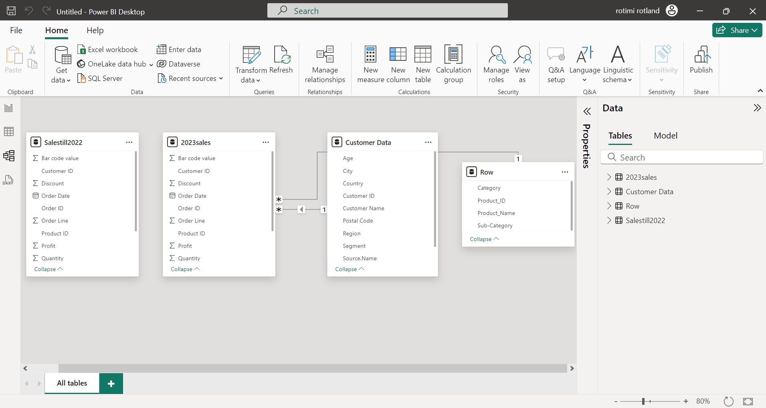

This is the model view showing the image of dataset after loading from various data source into powerBI

I used Power Query in PowerBI to carry out some modification & transformation to make our dataset ready for analysis.

Firstly, We merge two different dataset(customer table & sales table) to uncover more insight and I ensured a good naming system and also take note of the datatype of each column.